**STASTICAL MACHINE LEARNING APPROACHES TO LIVER DISEASE PREDICTION**

 **TEAM ID:PNT2022TMID13272**

**TEAM**  **MEMBERS**

                            KAMALI  R                              (621319104019)

                            DHARSHINI  S                        (621319104012)

                            MOHANA  R                            (621319104032)

                            SONA  R                                   (621319104054)

**TEAM MENTOR:**

                            Mr.R.Madnachitran.AP/CSE

**CHAPTER 1**

**INTRODUCTION**

Healthcare providers must get patient samples in order to diagnose disease, which can be expensive in terms of both time and money. Urinalysis, a complete blood count (CBC), and a comprehensive metabolic panel (CMP) are the most common tests. Exploratory data analysis techniques are crucial in the medical field because they can predict patterns across data sets, allowing for a quicker and more accurate identification of risk or diagnostic factors for disease. By using these techniques, liver illness may be detected sooner and may not proceed as far as to necessitate biopsy or involved treatment in many cases.

ML algorithms are cutting-edge methods for handling numerous hidden issues in medical data sets. This strategy can assist healthcare administrators and professionals in exploring improved outcomes in several clinical applications. Researchers and lab personnel have employed a variety of statistical and machine learning methodologies (such as simulation modelling, categorization, and inference) to improve prediction. The clinical outcomes rely more on data than they do models.

Finding the right target (response variable) and attributes for classification issues in medical diagnostics is particularly difficult. Although logistic regression is a commonly used method, its performance is inferior to several machine learning and deep learning techniques. As part of exploratory data analysis, data visualization is first required to comprehend latent information about predictors. 70% of fatalities globally are caused by liver disease. It is necessary to develop more precise methods for identifying and diagnosing liver disease. The availability and cost of liver function testing for patients should be prioritized. Application of statistical machine learning algorithms to CMP findings for the extraction of information for a doctor may aid with diagnosis by avoiding the costly and intrusive testing.

The application of statistical machine learning techniques to CMP findings for the extraction of information for a doctor may be helpful for diagnosis and help avoid the costly and invasive procedures . Exploratory data analysis techniques are crucial in the field of medicine because they can identify patterns in large data sets and speed up and improve the process of identifying risk or disease-related diagnostic indicators. By using these techniques, liver illness may be detected sooner and may not proceed as far as to necessitate biopsy or involved treatment in many cases.

**1.1 PROJEC OVERVIEW**

The improvement of patient care, research, and policy is significantly impacted by medical diagnoses. Medical practitioners employ a variety of pathological techniques to make diagnoses based on medical records and the conditions of the patients. Clinicians have recently been actively involved in enhancing medical diagnostics.

Disease identification has been significantly enhanced by the application of artificial intelligence and machine learning in conjunction with clinical data. In the present era, one may gather data and visualize various hidden outcomes, such as coping with missing data in medical research, thanks to the use of computers and technologies. One can make decisions with the help of statistical machine learning algorithms built for specific challenges.

Data-driven algorithms for machine learning (ML) can be used to test existing techniques and assist researchers in making possible new choices The goal of this work was to use ML algorithms to derive meaningful predictors of liver disease from the medical data of 615 persons. Data visualizations were used to highlight important discoveries, like missing values. Principal component analysis (PCA) was used to minimize the dimensional after multiple imputations by chained equations (MICEs) were employed to produce missing data points.

To confirm significant predictors discovered by PCA, variable importance ranking utilizing the Gini index was performed. The ML approaches employed testing data (ntest=216) to predict categories and training data (ntrain=399) for learning.

The study examined support vector machine, random forest (RF), and artificial neural network binary classifier machine learning methods using published liver disease data set. Intended to categorize people who have liver illnesses, enabling medical practitioners to provide a more accurate diagnosis.

To control over fitting issues, the minority class was over sampled using the synthetic minority oversampling technique. The RF considerably (p 0.001) contributed to an accuracy score of 98.14% that was higher than that of the other approaches. Inferring from this that ML algorithms predict liver illness by including risk factors may help with patient inference-based diagnosis.

**1.2 PURPOSE OF THE PROJECT**

In this liver prediction web application, the patient initially logs in to the website and can enters the details. Instead of having to navigate through multiple screens to enter each and every details. According to the details they have entered their result will be displayed on the page without the use of the doctor.

To overcome this problem of binary classification, supervise is required. Each data point comprises ten attributes, and a label indicating whether the patient has liver disease or not appears next to each property. Our objective should be to train a range of supervised learning models on this data set to produce a high-performing model that can precisely classify any new data point as positive or negative and surpass the benchmarks in order to discover the solution.

1. **PURPOSE**

Using this liver prediction patient can able to know their health condition unless help from the doctor or the specialist. The page created is very efficient to use and it can be easily operated by each and everyone. The algorithm used are for the efficient calculation.

**2) FEASIBILITY STUDY**

The extent to which a company will profit from or be able to implement an informant system. The issue's feasibility is evaluated. The Statistical Machine Learning Approach to Liver Disease Prediction project has so far concentrated on the following two main categories of feasibility study.

* **Technical Feasibility**

It evaluates the efficiency of the technology solution as well as the accessibility of technical expertise and resources. What is practical and reasonable is referred to as "technical feasibility." It largely addresses their main worries.

* **Operational Feasibility**

How well a project will support the client and service provider during the operational phase determines its operational viability.

**CHAPTER 2**

**LITERATURE SURVEY**

1. **TITLE: Jaganathan, K.; Tayara, H.; Chong, K.T. Prediction of Drug-Induced Liver Toxicity Using SVM and Optimal Descriptor Sets. Int. J.Mol. Sci. 2021, 22, 8073. [CrossRef]**

**AUTHOR: Jaganathan, K.; Tayara, H.; Chong, K.T./2021**

The prediction model is determined by molecular descriptors and the software such as PaDEL, Chemopy, CDK and RDKit.

Non genetic risk factors include age, chronic liver diseases and other diseases. Compound-specific risk factors include daily dose, metabolism characteristics and propensity for drug interaction. This prediction is to improve the liver toxicity

**[2] TITLE: Saillard, C.; Schmauch, B.; Laifa, O.; Moarii, M.; Toldo, S.; Zaslavskiy, M.; Pronier, E.; Laurent, A.; Amaddeo, G.; Regnault, H.;et al. Predicting survival after hepatocellular carcinoma resection using deep-learning on histological slides. Hepatology 2020, 72,2000–2013. [CrossRef]**

**AUTHOR: Saillard,C.; Schmauch,B.; Pronier,E.; Laurent,A.; Amaddeo,G.; Regnault, H.;/2020**

Machine learning algorithms, salable and adaptive to complex patterns, may be particularly well suited. The power of building strong models from a large number of weakly predictive features, and the ability to identify key factors in complex feature sets. Predicting operational events, and identifying key workflow drivers

**[3] TITLE:Singh, J.; Bagga, S.; Kaur, R. Software-based Prediction of Liver Disease with Feature Selection and Classification Techniques.Procedia Comput. Sci. 2020, 167, 1970–1980. [CrossRef]**

**AUTHOR: Singh,J.;Bagga, S.;Kaur, R./2020**

Decision tree algorithm is used, Naive Bayes and neural filtration algorithm. The algorithm decision tree classifies the given data by dividing them into nodes and branches. By applying decision tree classifier classification of yes or no about the grant patent check is done. It increases classification accuracy and also leads to reduction in classification time. It aids for prediction of liver disease more efficiently. The performance is measured in terms of accuracy, auc score, precision, recall and measure.

**[4]TITLE:Wang, Y.; Li, Y.; Wang, X.; Gacesa, R.; Zhang, J.; Zhou, L.; Wang, B. Predicting Liver Disease Risk Using a Combination of Common Clinical Markers: A Screening Model from Routine Health Check-Up. Dis. Markers 2020, 2020, 8460883.**

**AUTHOR: Wang,Y.; Gacesa,R.; Zhang, J.; Wang, B/2020**

Observational retrospective study and analyzed 581 AILD patients who were hospitalized Gastroenterology department and 1000 healthy controls who were collected from health management center. Prediction models combine several variables or features to estimate the risk of people being infected experiencing a poor outcome from infection could assist medical staff in the treatment of patients, especially those that develop organ failure such as that of the liver. To analyze clinical characteristics of AILD patients at initial presentation and identify clinical markers

**[5]TITLE: Asrani, S.K.; Devarbhavi, H.; Eaton, J.; Kamath, P.S. Burden of liver diseases in the world. J. Hepatol. 2019, 70, 151–171.**

**AUTHOR: Asrani,S.K.; Devarbhavi,H.; Eaton,J.; Kamath, P.S/ 2019**

The global prevalence of viral hepatitis remains high, while drug-induced liver injury continues to increase as a major cause of acute hepatitis. Vaccination and newer drugs will reduce the burden of viral related liver disease. This prediction for prevalence of the most common causes of chronic liver diseases in the United States from 1988 to 2008.

1. **TITLE: Chalasani, N.; Younossi, Z.; Lavine, J.E.; Charlton, M.; Cusi, K.; Rinella, M.; Harrison, S.A.; Brunt, E.M.; Sanyal, A.J. The diagnosis and management of nonalcoholic fatty liver disease: Practice guidance from the American Association for the Study of Liver Diseases. Hepatology 2018, 67, 328–357.**

**AUTHOR: Chalasani,N.; Younossi,Z.; Harrison,S.A.; Brunt,E.M.; Sanyal,A.J/2018**

The mechanism of nonalcoholic fatty liver disease is unknown but involves the development of insulin resistance, steatosis, inflammatory cytokines, and oxidative stress. Screening is not recommended in the general population. The bases for current methods of evaluating the lesions that collectively comprise the phenotype spectra of NAFLD.

**2.1 EXISTING SYSTEM**

An extensive study of the problem shows that there are only two systems in the same domain. The system is purely manual, to start. It has the ability to store medical records and patient information. The main features of the early system are as follows. Compared to the first system, the second is more efficient. An associated research study revealed that the system is built utilising the KNN approach.

Unsurprisingly, one of the most often used paradigms of big data management is machine learning, where a large amount of diverse raw data may be combined successfully to draw the proper conclusions and ultimately produce a typical collection of contextually meaningful information.

**2.2 REFERENCE**

1. Jaganathan, K.; Tayara, H.; Chong, K.T. Prediction of Drug-Induced Liver Toxicity Using SVM and Optimal Descriptor Sets. Int. J.Mol. Sci. 2021, 22, 8073. [CrossRef]

1. Saillard, C.; Schmauch, B.; Laifa, O.; Moarii, M.; Toldo, S.; Zaslavskiy, M.; Pronier, E.; Laurent, A.; Amaddeo, G.; Regnault, H.;et al. Predicting survival after hepatocellular carcinoma resection using deep-learning on histological slides. Hepatology 2020, 72,2000–2013. [CrossRef]
2. Phan, D.V.; Chan, C.L.; Li, A.A.; Chien, T.Y.; Nguyen, V.C. Liver cancer prediction in a viral hepatitis cohort: A deep learning approach. Int. J. Cancer 2020, 147, 2871–2878. [CrossRef]
3. Singh, J.; Bagga, S.; Kaur, R. Software-based Prediction of Liver Disease with Feature Selection and Classification Techniques.Procedia Comput. Sci. 2020, 167, 1970–1980. [CrossRef]
4. Pianykh, O.S.; Guitron, S.; Parke, D.; Zhang, C.; Pandharipande, P.; Brink, J.; Rosenthal, D. Improving healthcare operations management with machine learning. Nat. Mach. Intell. 2020, 2, 266–273. [CrossRef]
5. Wang, Y.; Li, Y.; Wang, X.; Gacesa, R.; Zhang, J.; Zhou, L.; Wang, B.Predicting Liver Disease Risk Using a Combination of Common Clinical Markers: A Screening Model from Routine Health Check-Up. Dis. Markers 2020, 2020, 8460883.
6. Asrani, S.K.; Devarbhavi, H.; Eaton, J.; Kamath, P.S. Burden of liver diseases in the world. J. Hepatol. 2019, 70, 151–171.
7. Hughes, R.A.; Heron, J.; Sterne, J.A.; Tilling, K. Accounting for missing data in statistical analyses: Multiple imputation is not always the answer. Int. J. Epidemiol. 2019, 48, 1294–1304.
8. Joloudari, J.H.; Saadatfar, H.; Dehzangi, A.; Shamshirband, S. Computer-aided decision-making for predicting liver disease using PSO-based optimized SVM with feature selection. Inform. Med. Unlocked 2019, 17.
9. Chalasani, N.; Younossi, Z.; Lavine, J.E.; Charlton, M.; Cusi, K.; Rinella, M.; Harrison, S.A.; Brunt, E.M.; Sanyal, A.J. The diagnosis and management of nonalcoholic fatty liver disease: Practice guidance from the American Association for the Study of Liver Diseases. Hepatology 2018, 67, 328–357.

**CHAPTER 3**

**IDEATION & PROPOSED SOLUTION**

**3.1 EMPATHY MAP CANVAS**

Empathy maps are created with the patient's availability in mind. This procedure is primarily for those who are experiencing disease symptoms and are unable to see a doctor for a regular examination.

The pre-processing step is where the work begins. The acquired data underwent pre-processing in this step. The majority of the data from the data set was gathered.

Age, gender, total and direct bilirubin, alkaline phosphotase, alamine aminitransferase, aspartate aminotransferase, total protine, albumin, albumin and globulin ratio, as well as other.

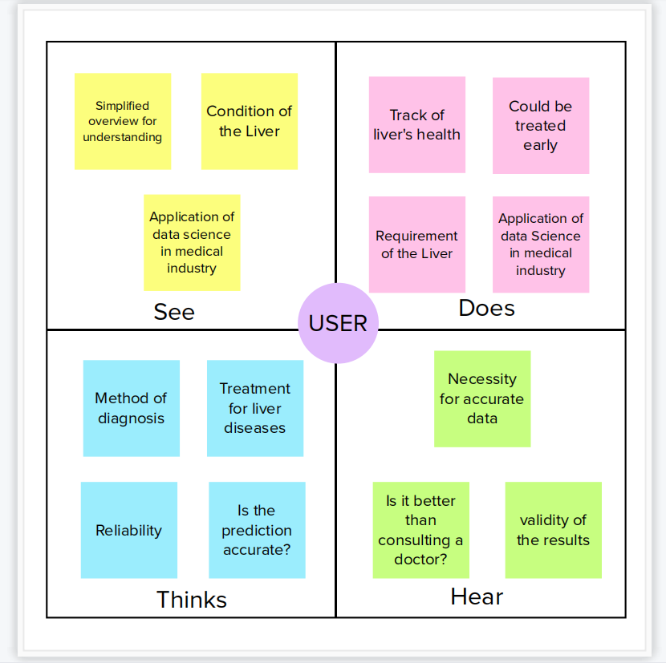

**3.2 IDEATION & BRAINSTORMING**

Ideation and brainstorming, a specific technique for generating new ideas, are typically closely related. The key difference between ideation and brainstorming is that ideation is often viewed as being more of a solo activity while brainstorming is almost always done in groups. People regularly come together for a brainstorming session to come up with either new, all-encompassing ideas or answers to particular issues or situations.

The line between ideation and brainstorming has become more hazy since the development of brainstorming software programmes like Bright idea and Idea wake. These software tools are designed to motivate staff members to come up with innovative solutions to improve operations and, ultimately, bottom-line profitability.

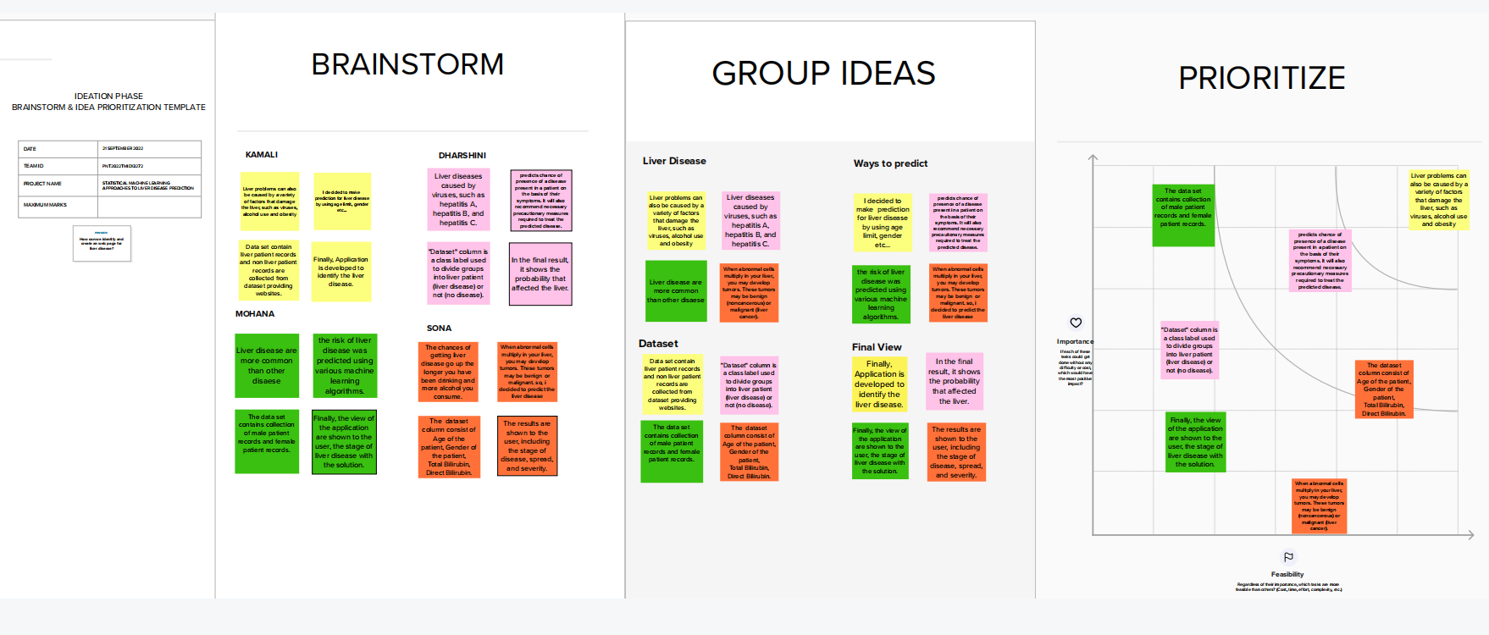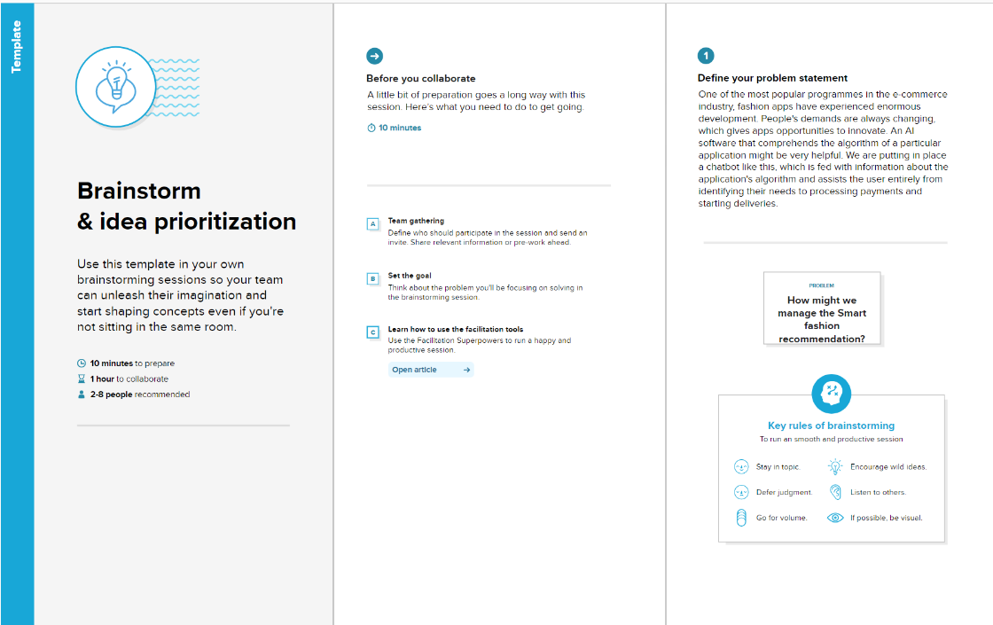

**3.3 PROPOSED SOLUTION**

The phrase "proposed solution" refers to the combination of all services (including any installation, implementation, training, maintenance, and support services) necessary to fulfil the goal specified by the vendor in its proposal, as well as any software, hardware, other goods or equipment.

Project team shall fill the following information in proposed solution;

1. **Problem Statement (Problem to be solved):**

For doctors and patients, identifying liver disease at an early stage is a challenging undertaking. The project's major goal is to analyse the data from liver patients by focusing on associations between a crucial list of liver proteins, age, and gender utilizing them to attempt to forecast the likelihood of developing liver disease**.**

1. **Idea / Solution description:**

The best accurate model to determine whether a person has liver disease or not will be built using a variety of machine learning (ML) algorithms. We intend to use data pre-processing and data visualization techniques to improve the model's accuracy before integrating the selected model into a Flask-based web application that will enable users to predict disease by entering parameters for simpler access and comprehension.

1. **Novelty / Uniqueness:**

To improve the model's accuracy, data pre-processing, which includes data cleaning, data transformation, and data reduction, is carried out.The most accurate machine model out of those that are implemented is chosen.The MSE, the confusion matrix, and several different metrics are used to assess the model output.

The rank of the output probabilities is taken into account by ROC-AUC, which assesses the chance that the model can differentiate between a positive and a negative point. To choose the most effective model from the many machine learning models, we will use AUC.

1. **Social Impact / Customer Satisfaction:**

Given that liver illness is more likely to occur great degree of accuracy, user will be able to act more quickly to correct things.

1. **Business Model (Revenue Model):**

By working with, one can earn money hospitals and related healthcare businesses the incorporation of subscription services application.

1. **Scalability of the Solution:**

By training the model with lots of data, accuracy can be improved. It is possible to train the model using user input. The people from all over the world can use the model that has been deployed on the web to estimate the likelihood of liver illness.

**3.4 PROBLEM SOLUTION FIT**

The Problem-Solution is a method used by business owners, marketers, and corporate innovators to identify ideas with a higher likelihood of being adopted, cut down on testing time, and develop a deeper comprehension of the current situation. The success of your business depends on this information, which is typically obtained "on the fly" after several rounds of revision and customer interviews. Based on the principles of Lean Startup and User Experience design, this canvas includes everything you need to identify patterns and determine what might work and why. Simply go where your customers are and meet a true need, whether it's the same issue handled differently or a brand-new concept delivered in a well-known manner. These are the requirements for this project.

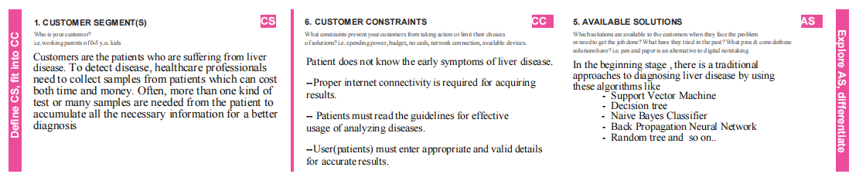

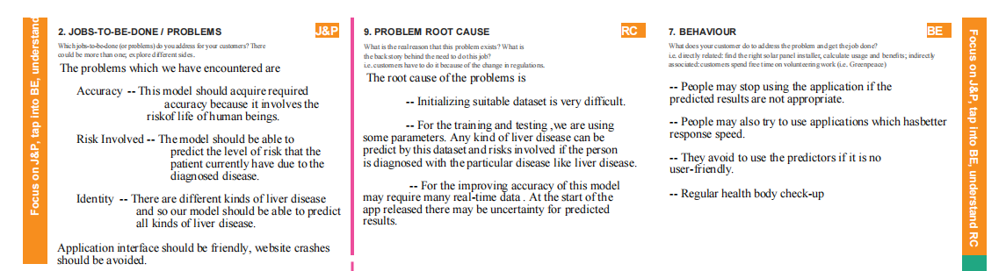

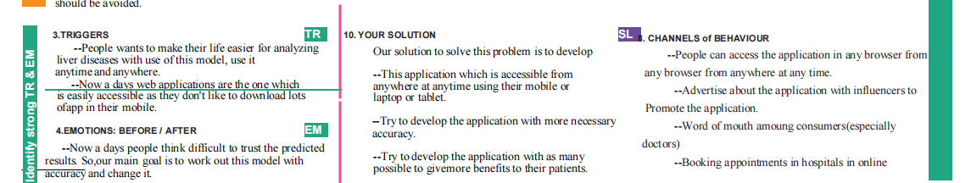

**CHAPTER 4**

**REQUIREMENT ANALYSIS**

**4.1 FUNCTION REQUIREMENT**

An explanation of the service that the software must provide is contained in a functional requirement (FR). It describes a piece of software or a software system.A computation, data manipulation, business process, user interaction, or any other specific aspect may be used to ascertain a system's likely function.

**4.1.1 USER REGISTERATION:**

Registration through Form

Registration through G-mail

**4.1.2 USER CONFERMITION:**

Confirmation via Email

Confirmation via OTP

**4.1.3 WEBSITE ENTRY:**

Collecting user’s data and storing it in the Database

**4.1.4 PERMISSIONS:**

Location

Storage

Contacts

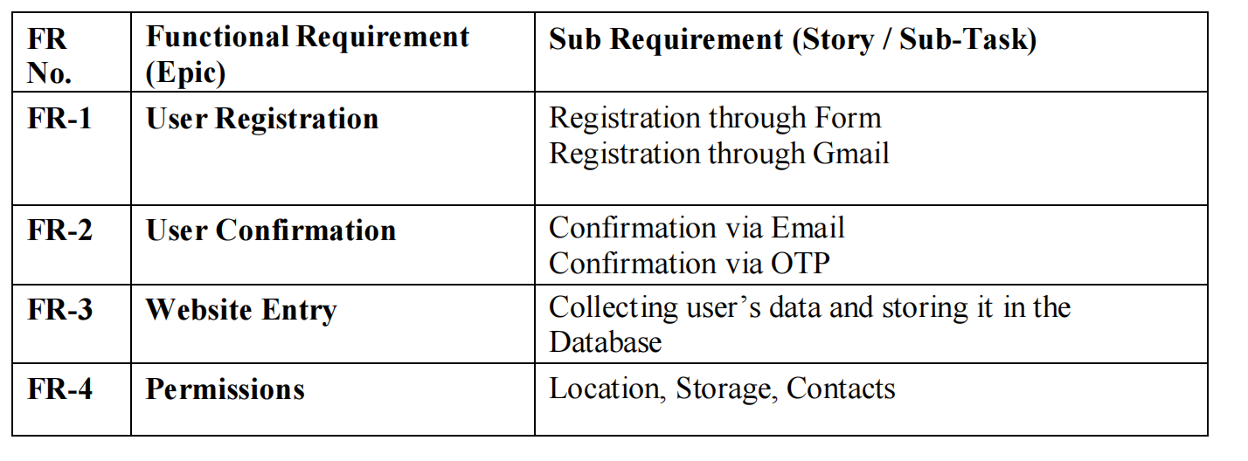

**4.2 NON-FUNCTIONAL REQUIREMENT**

Non-functional requirements are quality characteristics that specify how your product should behave. Basic non-functional criteria are included in the list.

**4.2.1 USABILITY:**

Establishes how challenging it will be for a user to understand and use the system. Usability can be accessed in various ways.

### 4.2.2 SECURITY:

Security requirements ensure that the software is protected from unauthorized access to the system and its stored in data.

**4.2.3 RELIABILITY:**

Reliability defines how likely it is for the software to work without failure for a given period. Reliability decreases because of bugs in the code , hardware failures and problems with other system component.

### 4.2.4 PERFORMANCE:

It is quality attribute that describers responsiveness of system to the various user interactions with it.

### 4.2.5 AVAILABILITY:

It is gauged by period that system’s functionality & services are available for use with all operations.

### 4.2.6 SCALABILITY:

Scalability describes how the system must grow without negative influence on its performance. This means serving more users , processing more data , doing more transactions . Website traffic limit must be scalable enough to support 2,00,000 users at a time.

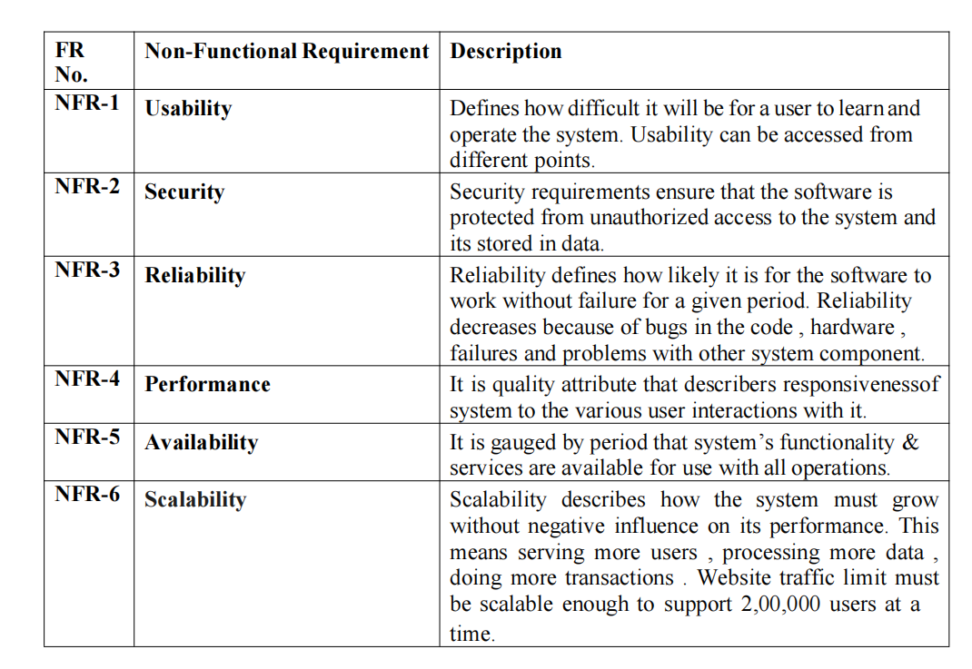

**CHAPTER 5**

**PROJECT DESIGN**

**5.1 DATA FLOW DIAGRAMS**

The information flows inside a system are traditionally shown visually in a data flow diagram (DFD). The appropriate amount of the system need can be graphically represented by a clean and unambiguous DFD. It demonstrates where data is stored, how it enters and leaves the system, and what modifies the data.

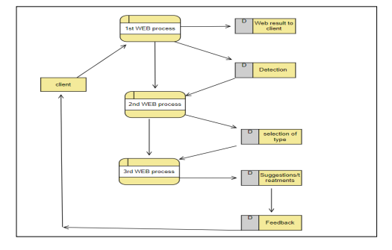

**5.2 SOLUTION & TECHNICAL ARCHITECTURE**

A solutions architect develops the overarching technical vision for a particular approach to solve a business issue. They conceptualism, outline, and oversee the solution.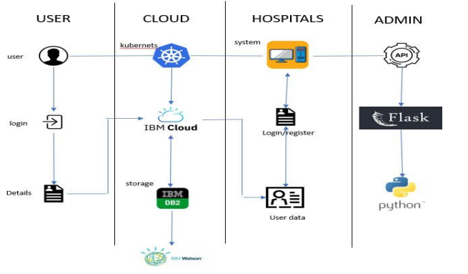

**5.3 USER STORIES**

A "user narrative" is a casual, generic explanation of a software feature written from the perspective of the client or end user. A user story explains how a piece of work will give the client a specific value.

**Component and Technologies:**

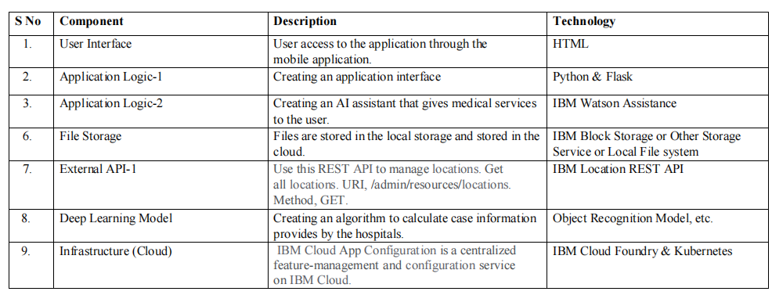

**Application Characteristics:**

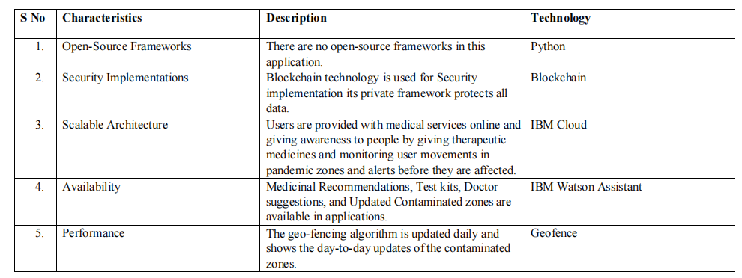 **CHAPTER 6**

**PROJECT PLANNING & SCHEDULING**

**6.1 SPIRIT PLANNING & ESTIMATION**

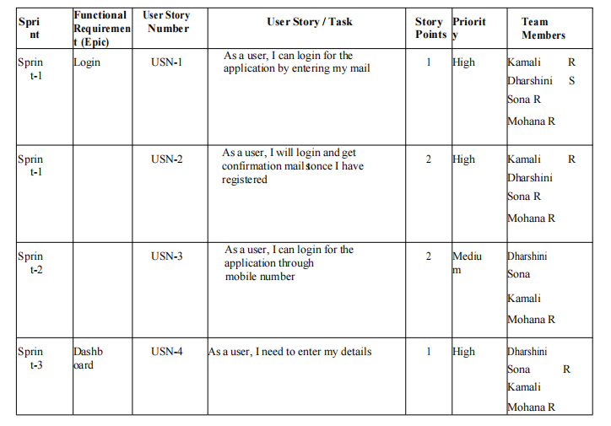

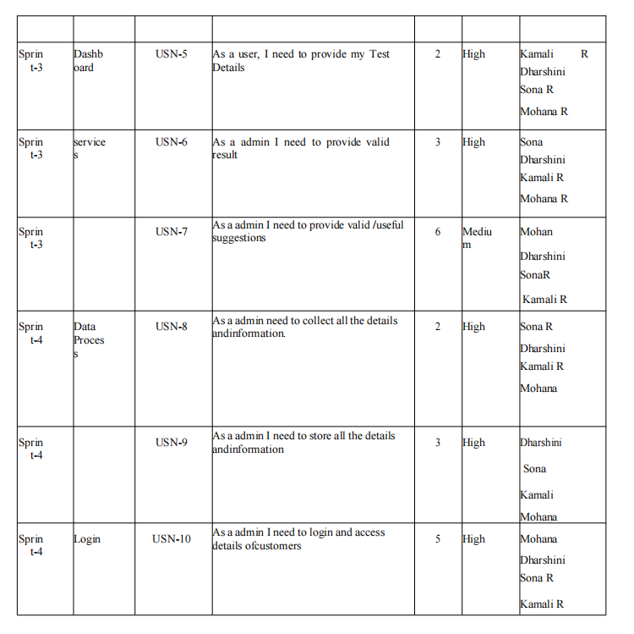



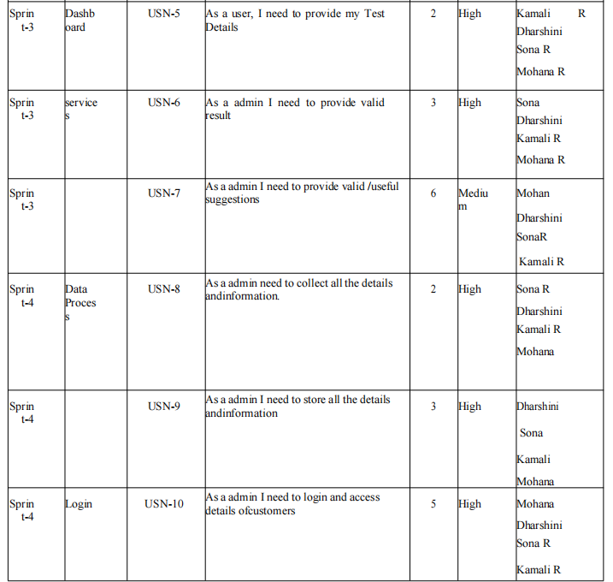

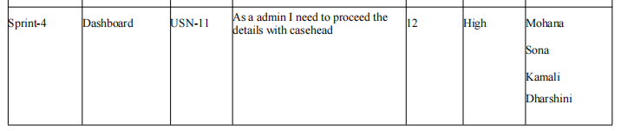

**6.2 SPRINT DELIVERY SCHEDULE**

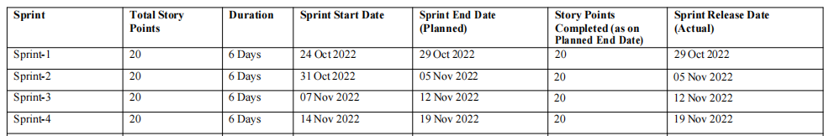

**6.3 REPORT FROM JIRA**

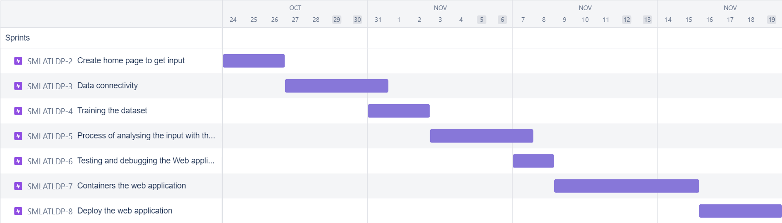

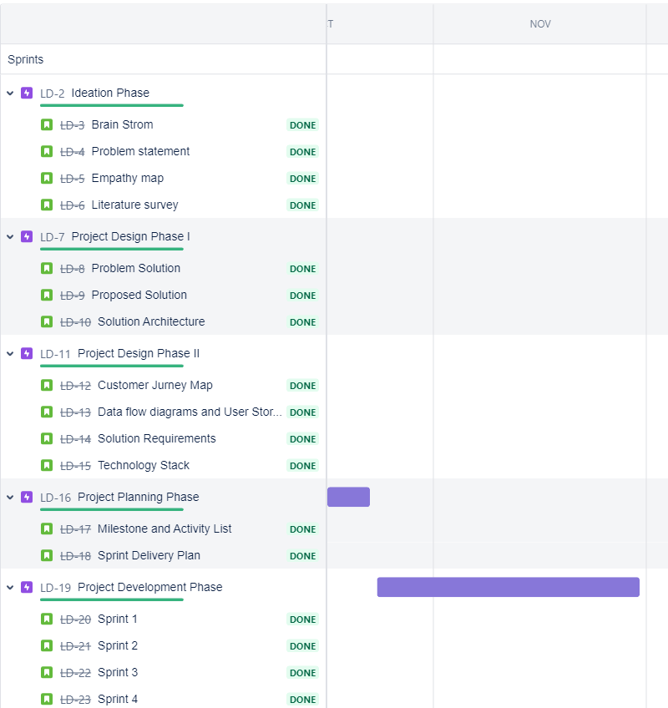

**CHAPTER 7**

**CODING & SOLUTIONING**

**7.1 FEATURE**

The patient wants to know about the state of their health and for that they have to enter the details of the required field. The patient can enter the details in the web-page which is get integrated with the cloud and and is connected using the flask.

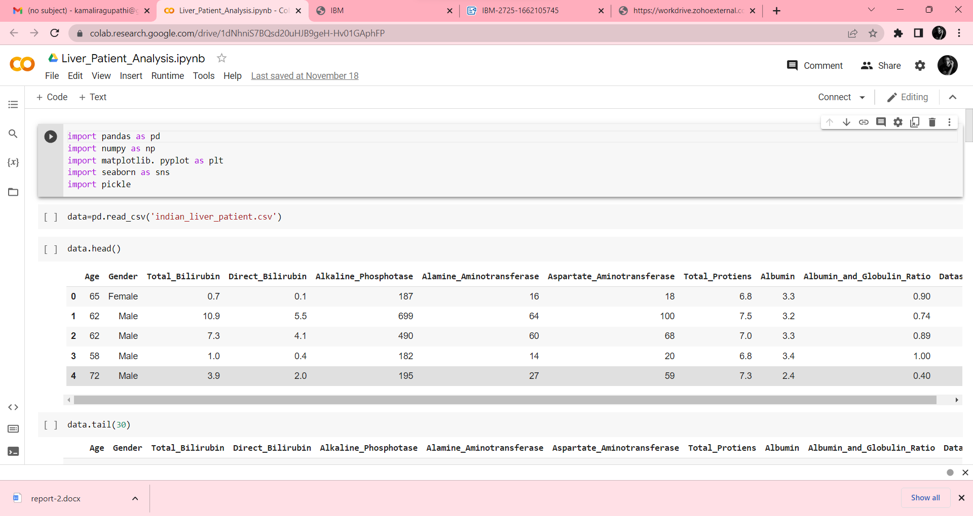

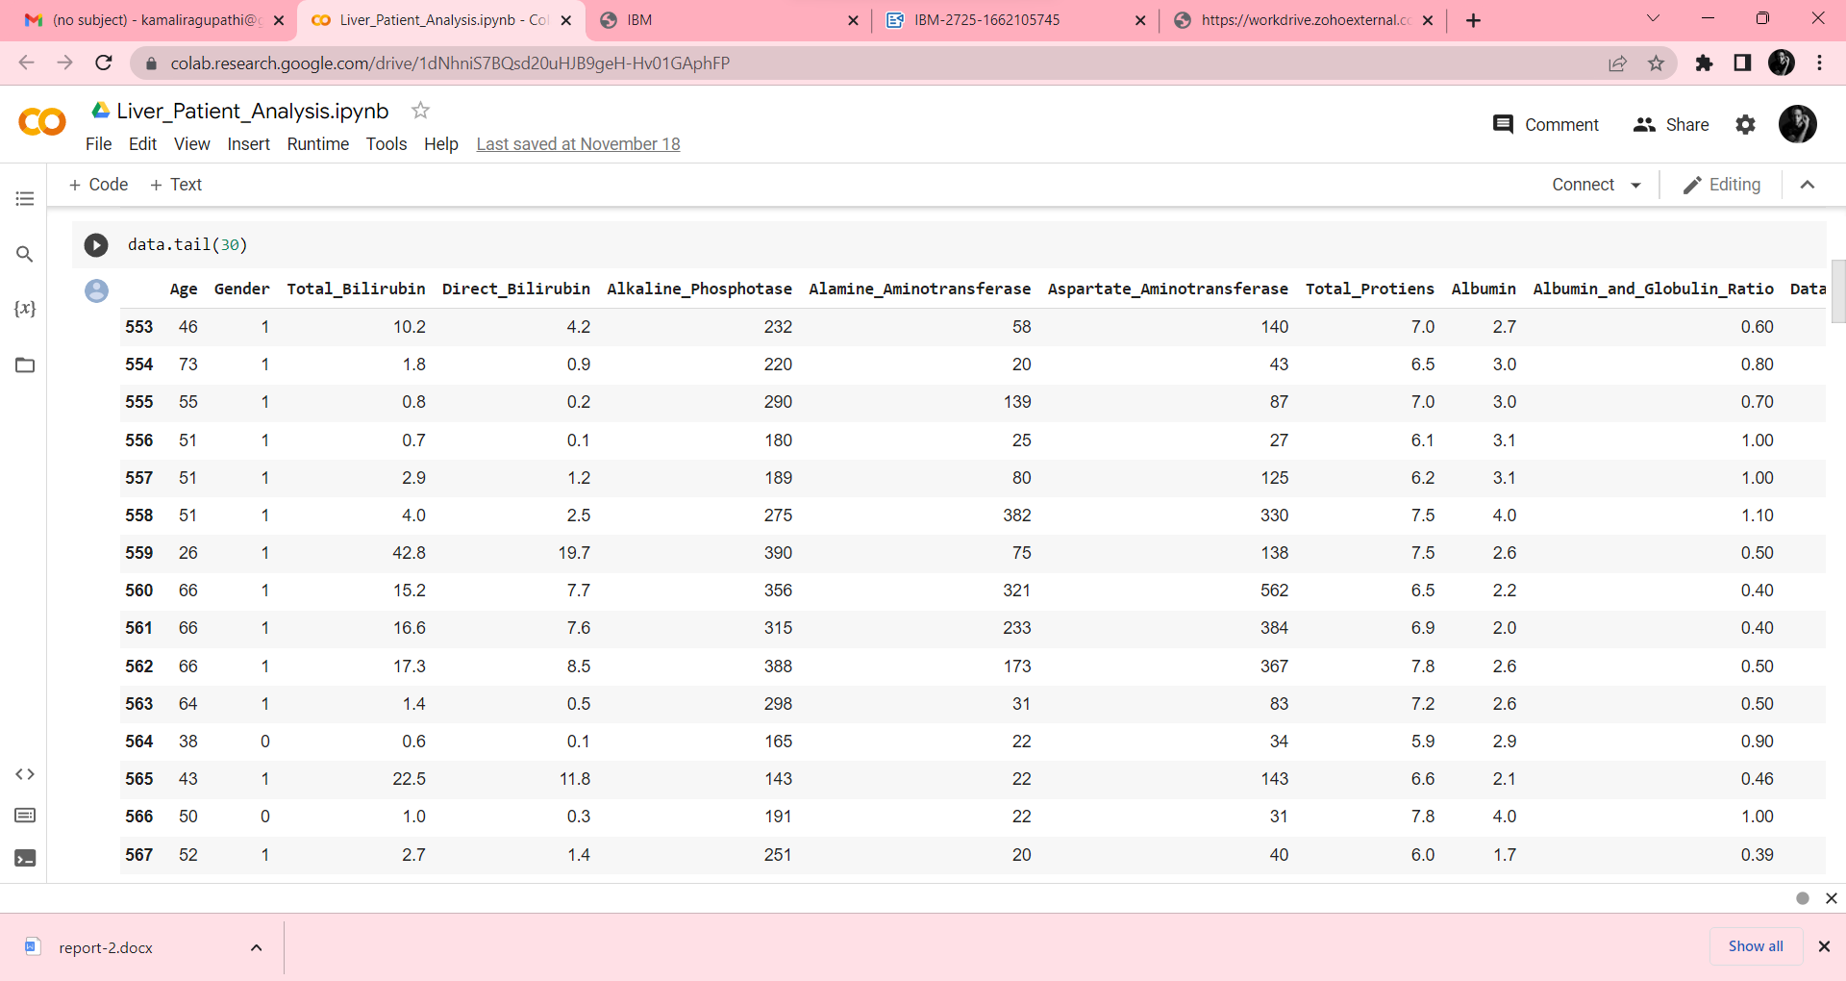

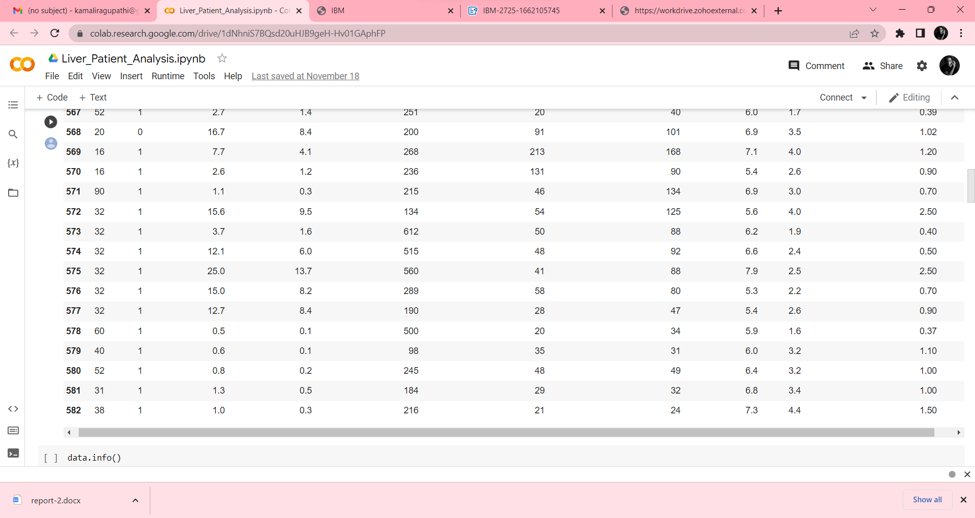

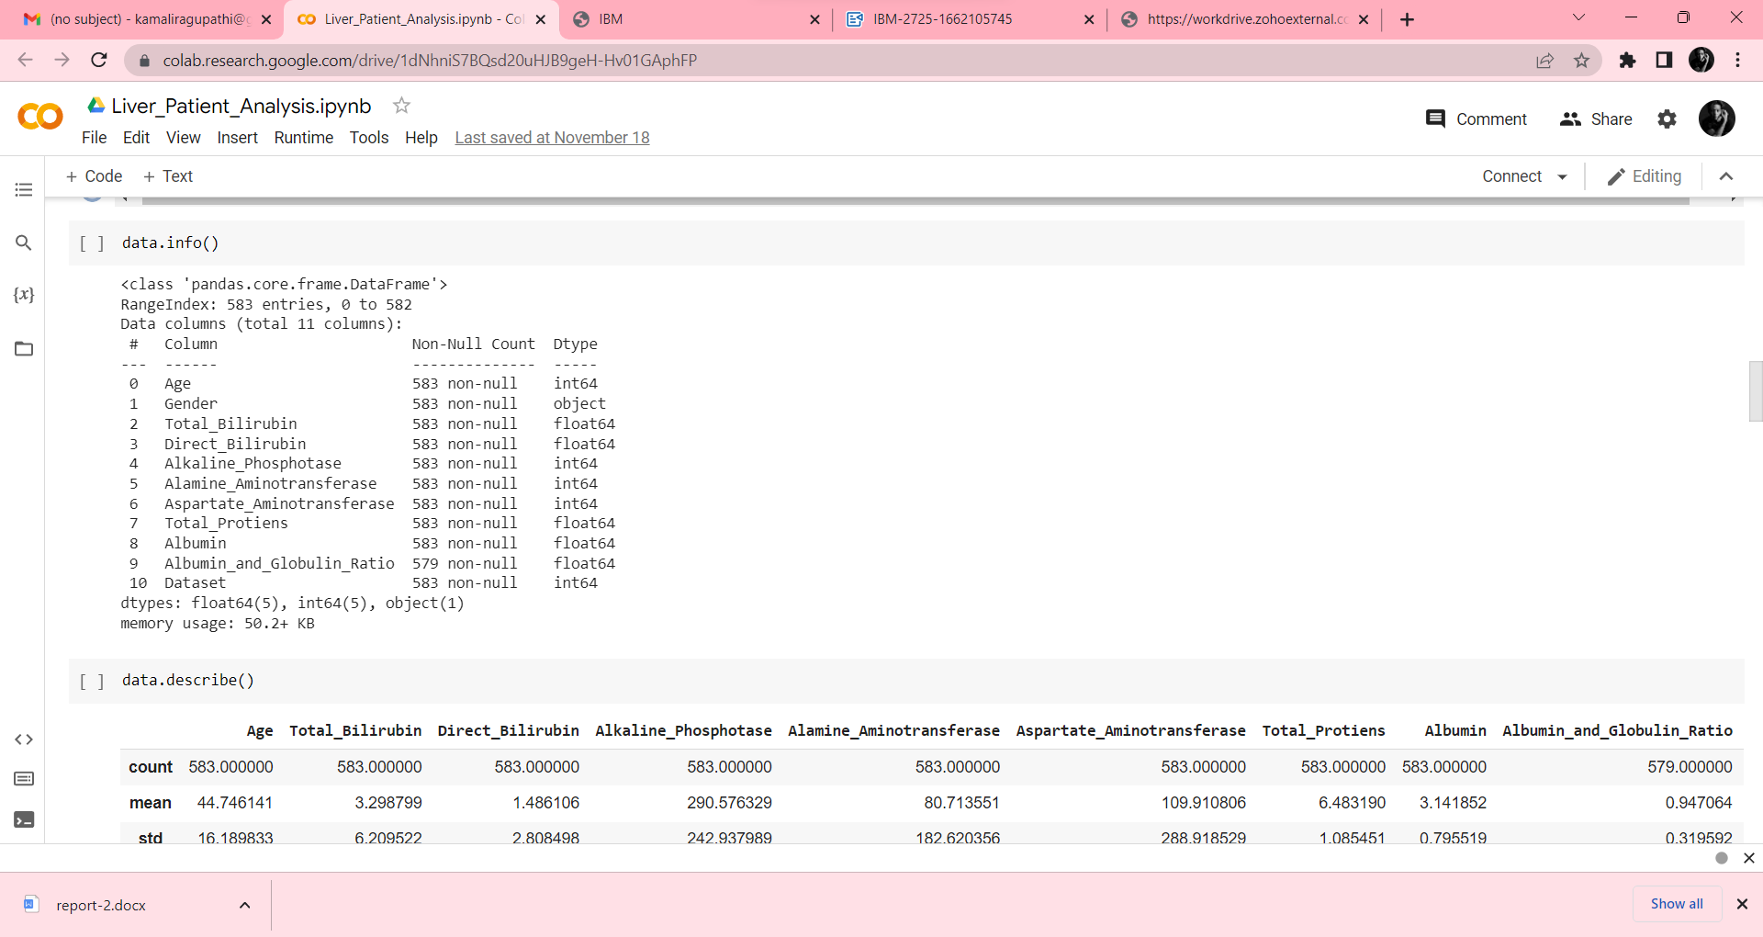

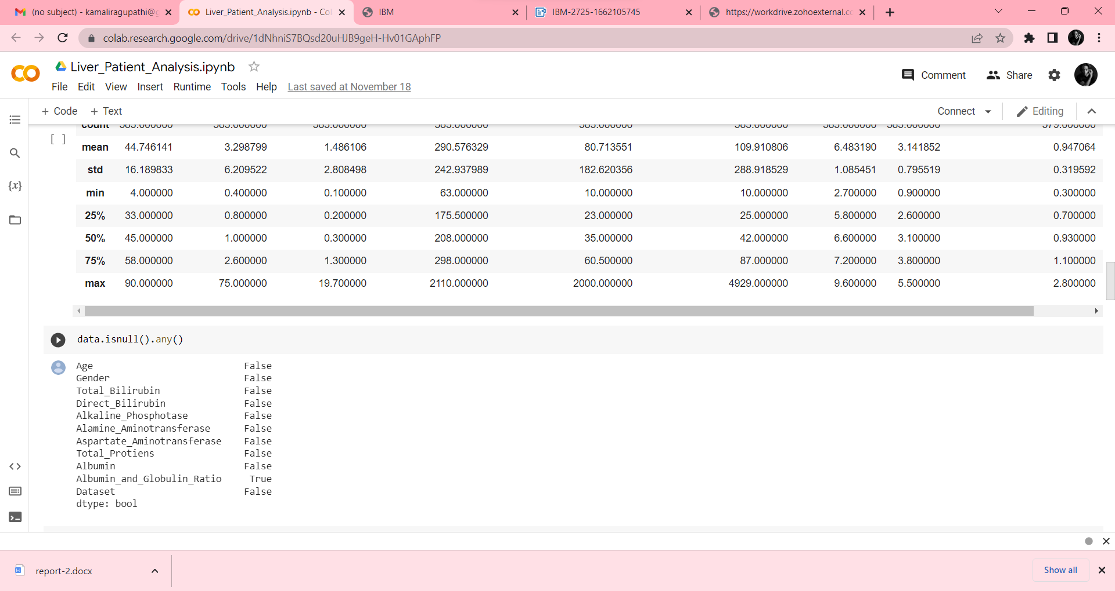

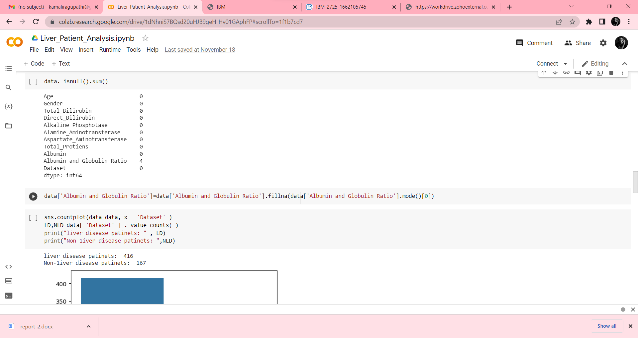

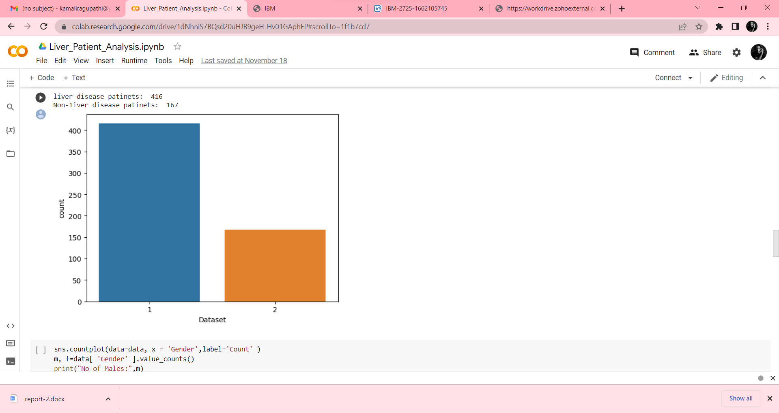

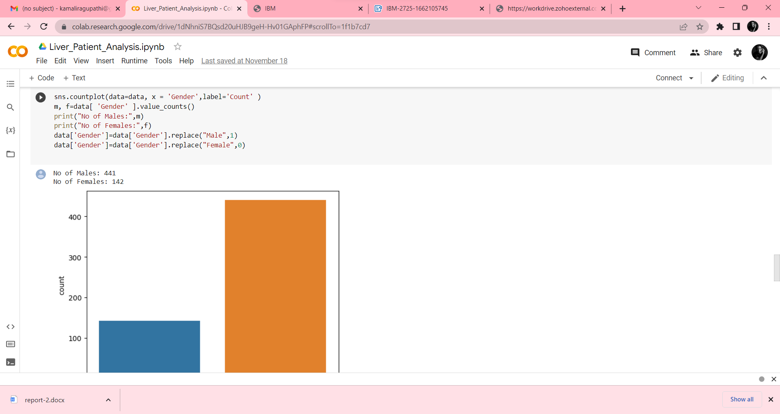

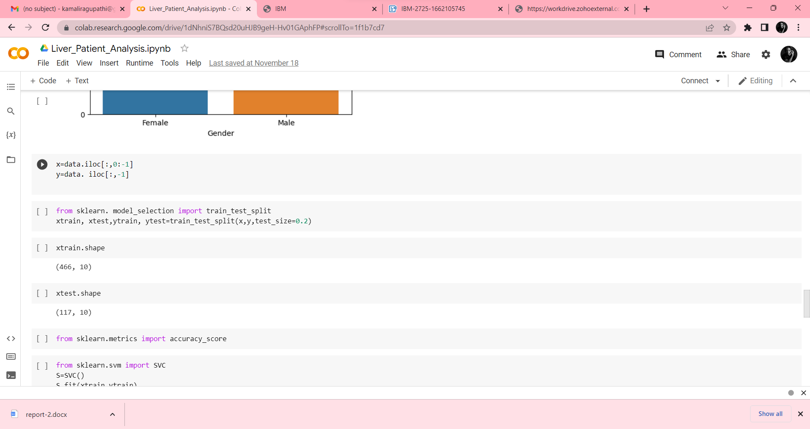

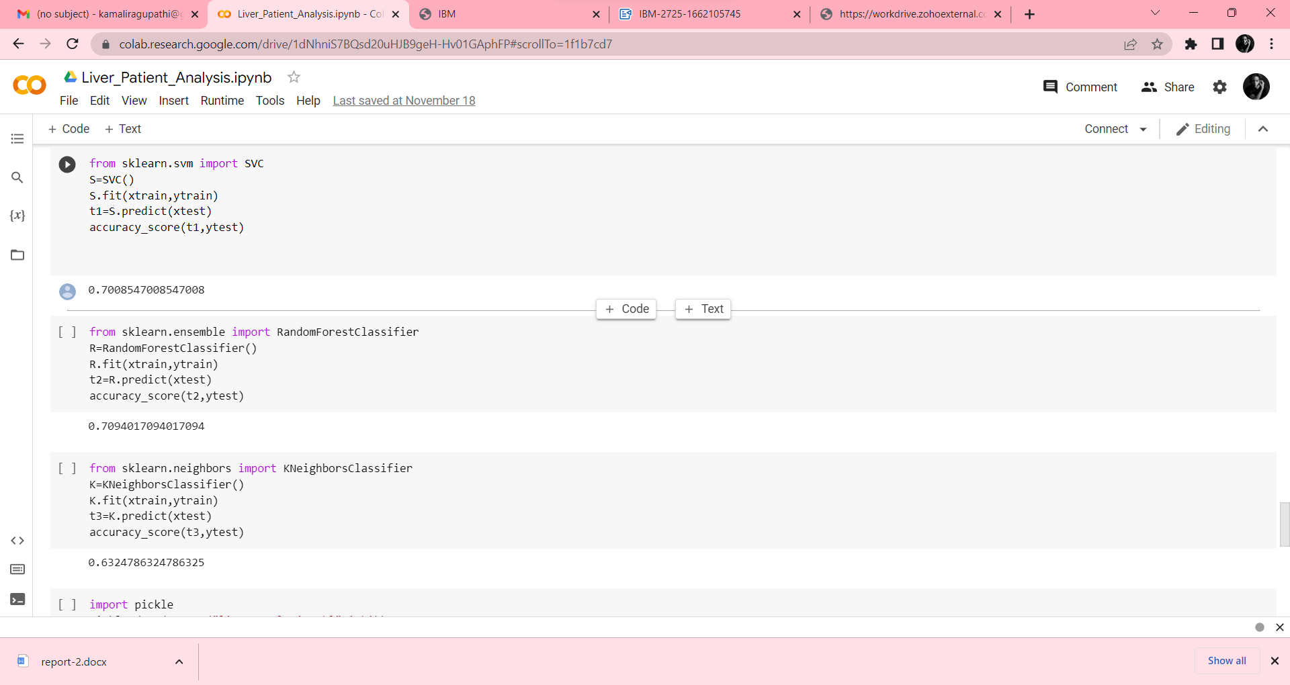

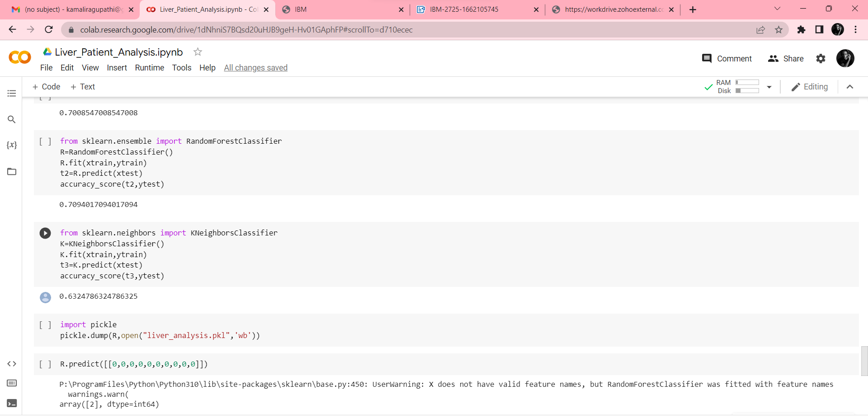

**7.2 FEATURE 2**

**HOME.HTML**

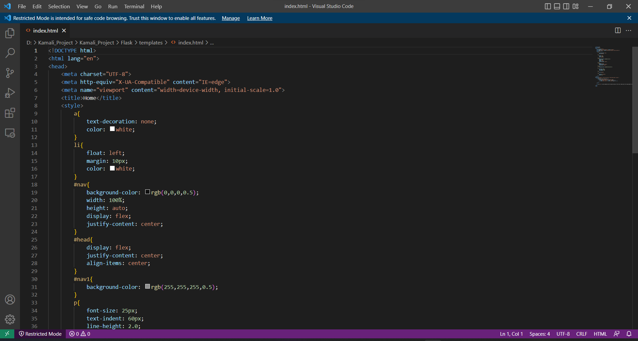

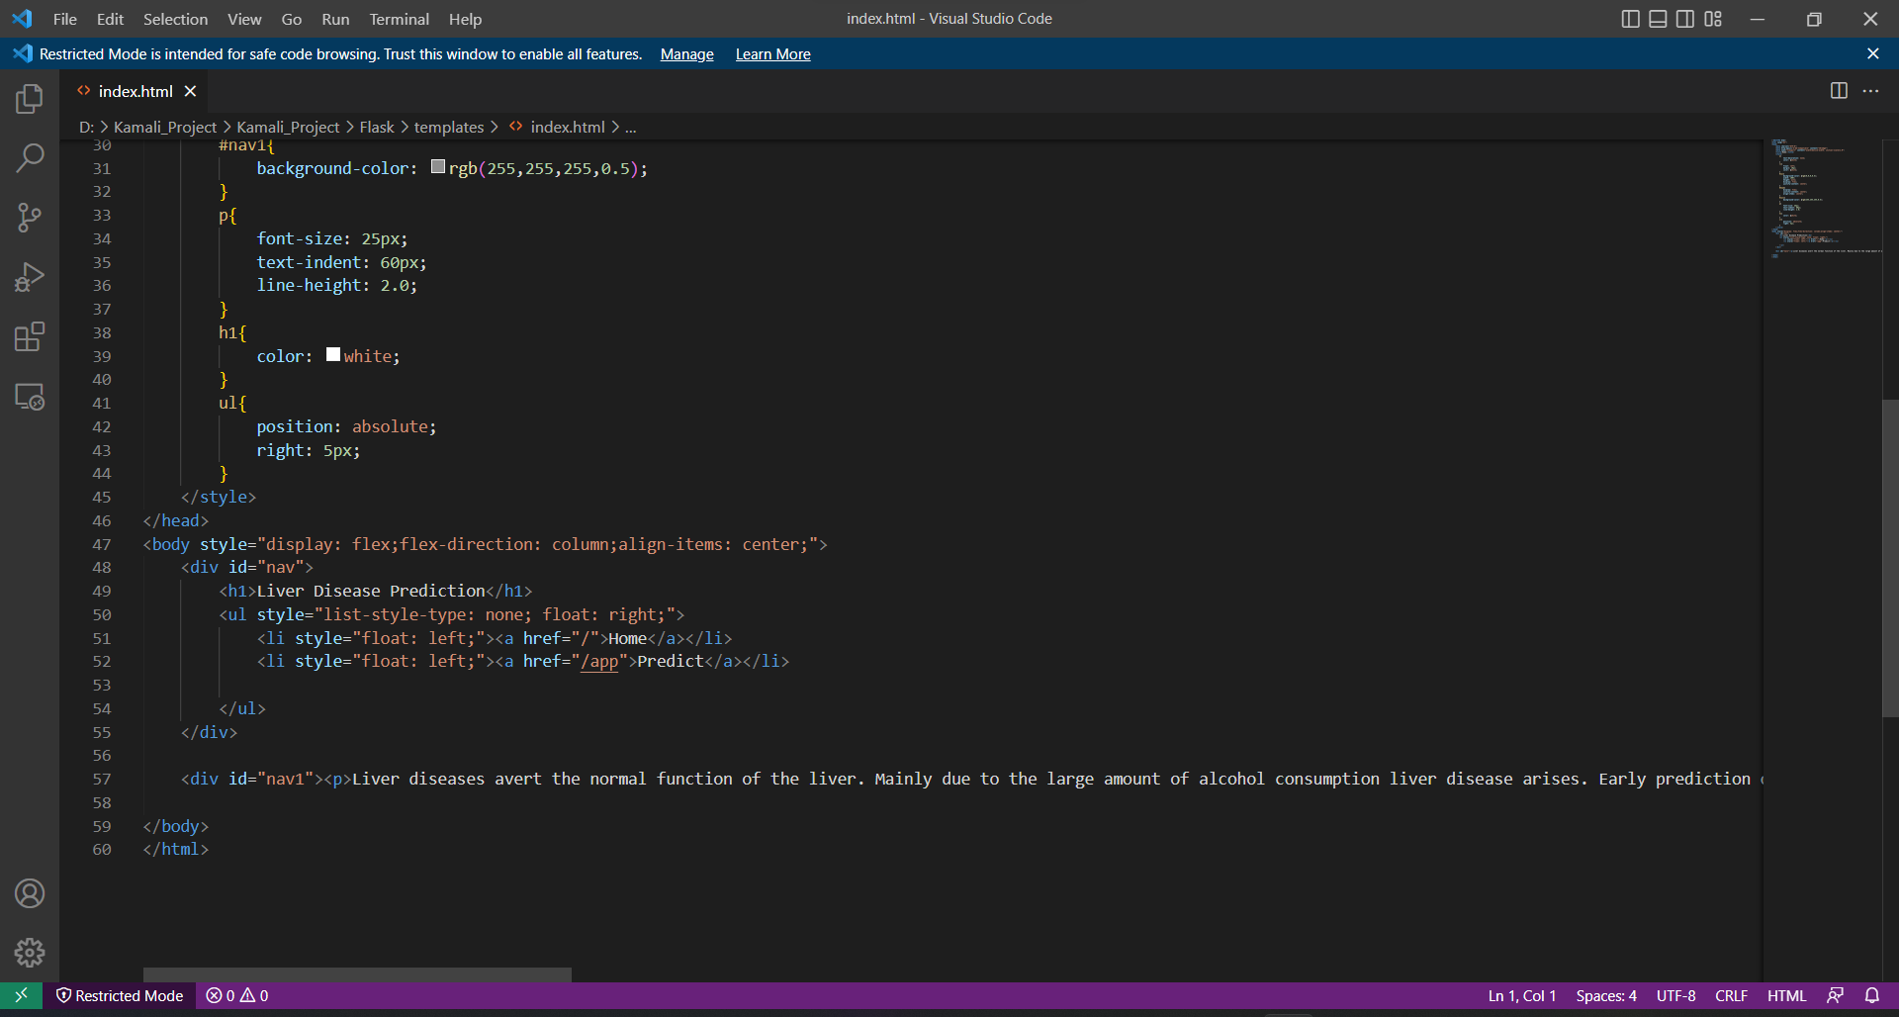

**CHAPTER 8**

**TESTING**

**8.1 TEST CASE**

|  |  |  |  |  |  |  |  |  |  |
| --- | --- | --- | --- | --- | --- | --- | --- | --- | --- |
| **Test case ID** | **Feature Type** | **Component** | **Test Scenario** | **Steps To Execute** | **Expected Result** | **Actual Result** | **Status** | **BUG ID** | **ExecutedBy** |
| HP_TC_001 | UI | Home Page | Verify UI elements in the Home Page | 1) Open the page      2) You can see the description           about process | The Home page description can be displayed properly | Working as expected | PASS |  | Sona R,    Mohana R |
| BE_TC_001 | Functional | Backend | Check if all the routes are working  properly | 1) Go to Home Page             2) Search the result button             3) Click the result button | All the routes should properly work | Working as expected | PASS |  | Sona R,    Mohana R |
| M_TC_002 | Functional | Model | Check if the model predicts the digit | 1) Open the page             2) Click on result button             3) Enter the input number            4) Check the results | The model should predict the number | Working as expected | PASS | Sona R,    Mohana R |
| M_TC_003 | Functional | Model | Check if the model can handle complex input number | 1) Open the page              2) Click on select button              3) Select the input number              4) Check the results | The model should predict the number in the complex data | The model fails to identify the digit since the model is not built to handle such data | FAIL | BUG_M_001 | Sona R,  Mohana R |
| RP_TC_001 | UI | Result Page | Check if the input  is displayed properly | 1) Open the page  2) Click on result button    3) enter the input number      4) Check if the input number           are displayed properly | The input number should be displayed properly | The size of the input percentage  exceeds the display container | FAIL | BUG_RP_001 | Sona R ,    Mohana R |
| RP_TC_002 | UI | Result Page | Check if the result is displayed properly | 1) Open the page  2) Click on result button    3) enter the input number      4) Check if the input number           are displayed properly | The result should be displayed properly | Working as expected | PASS |  | Sona R,    Mohana R |

**8.2 USER ACCEPTANCE TESTING**

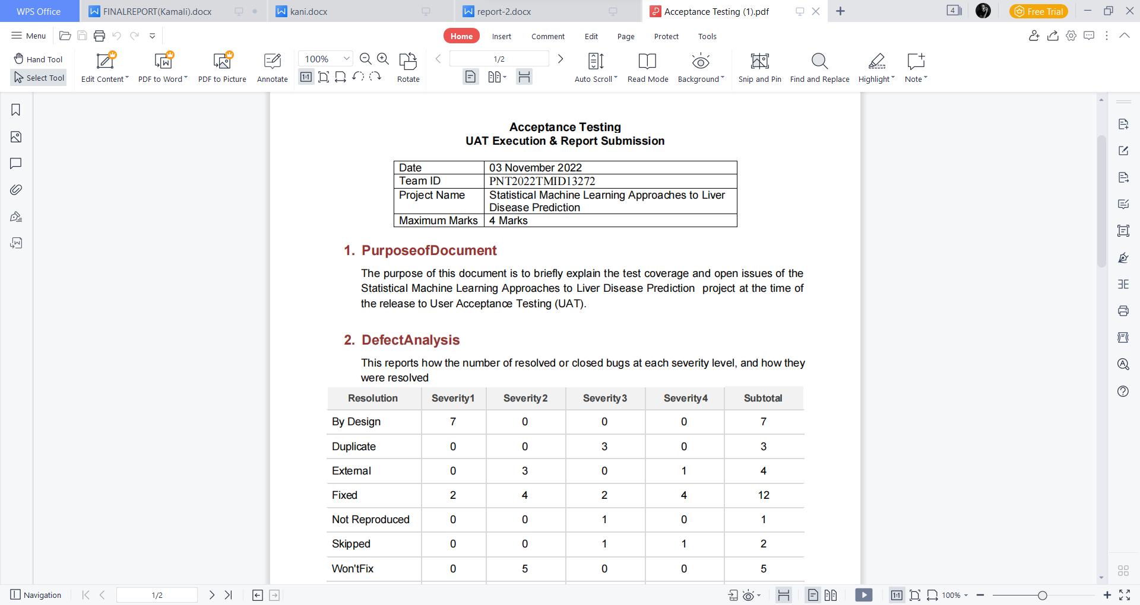

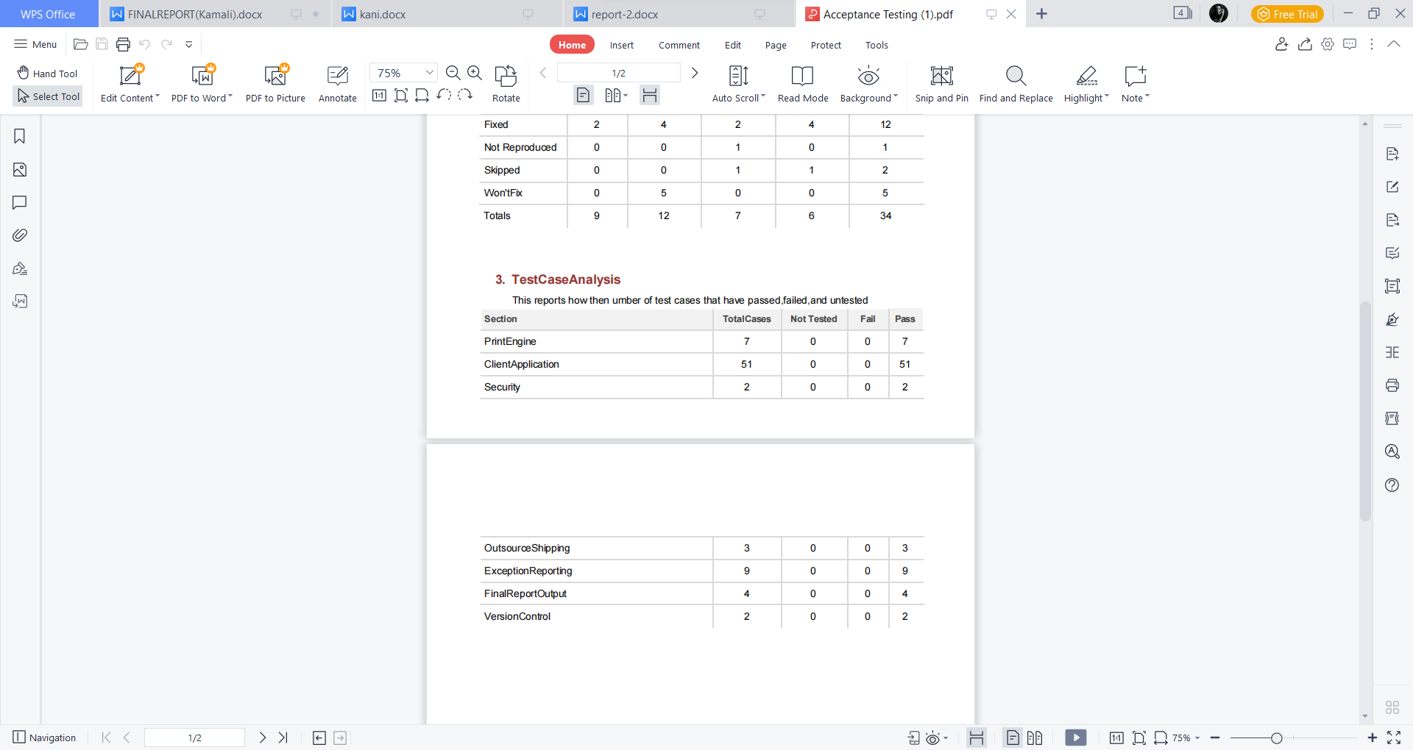

**CHAPTER 9**

**RESULTS**

**9.1 PERFORMANCE METRICS**

**Building HTML page:**

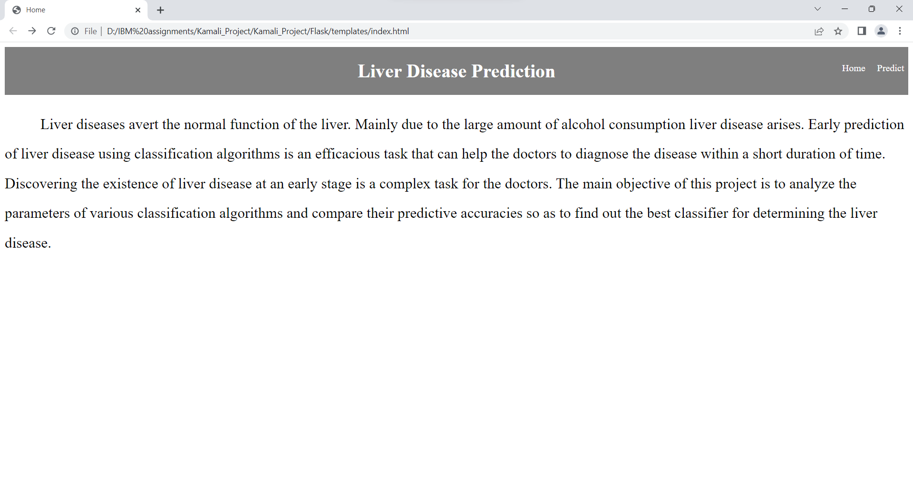

**Running Web Application:**

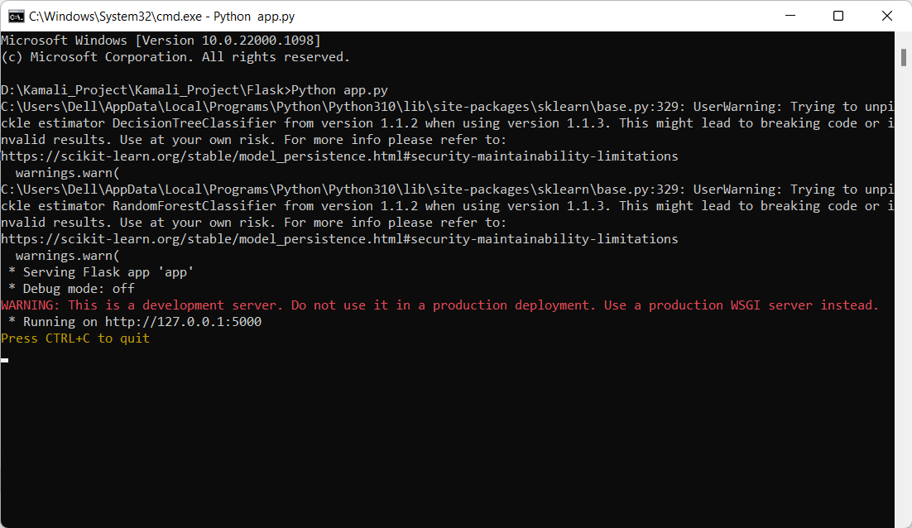

**Prediction page:**

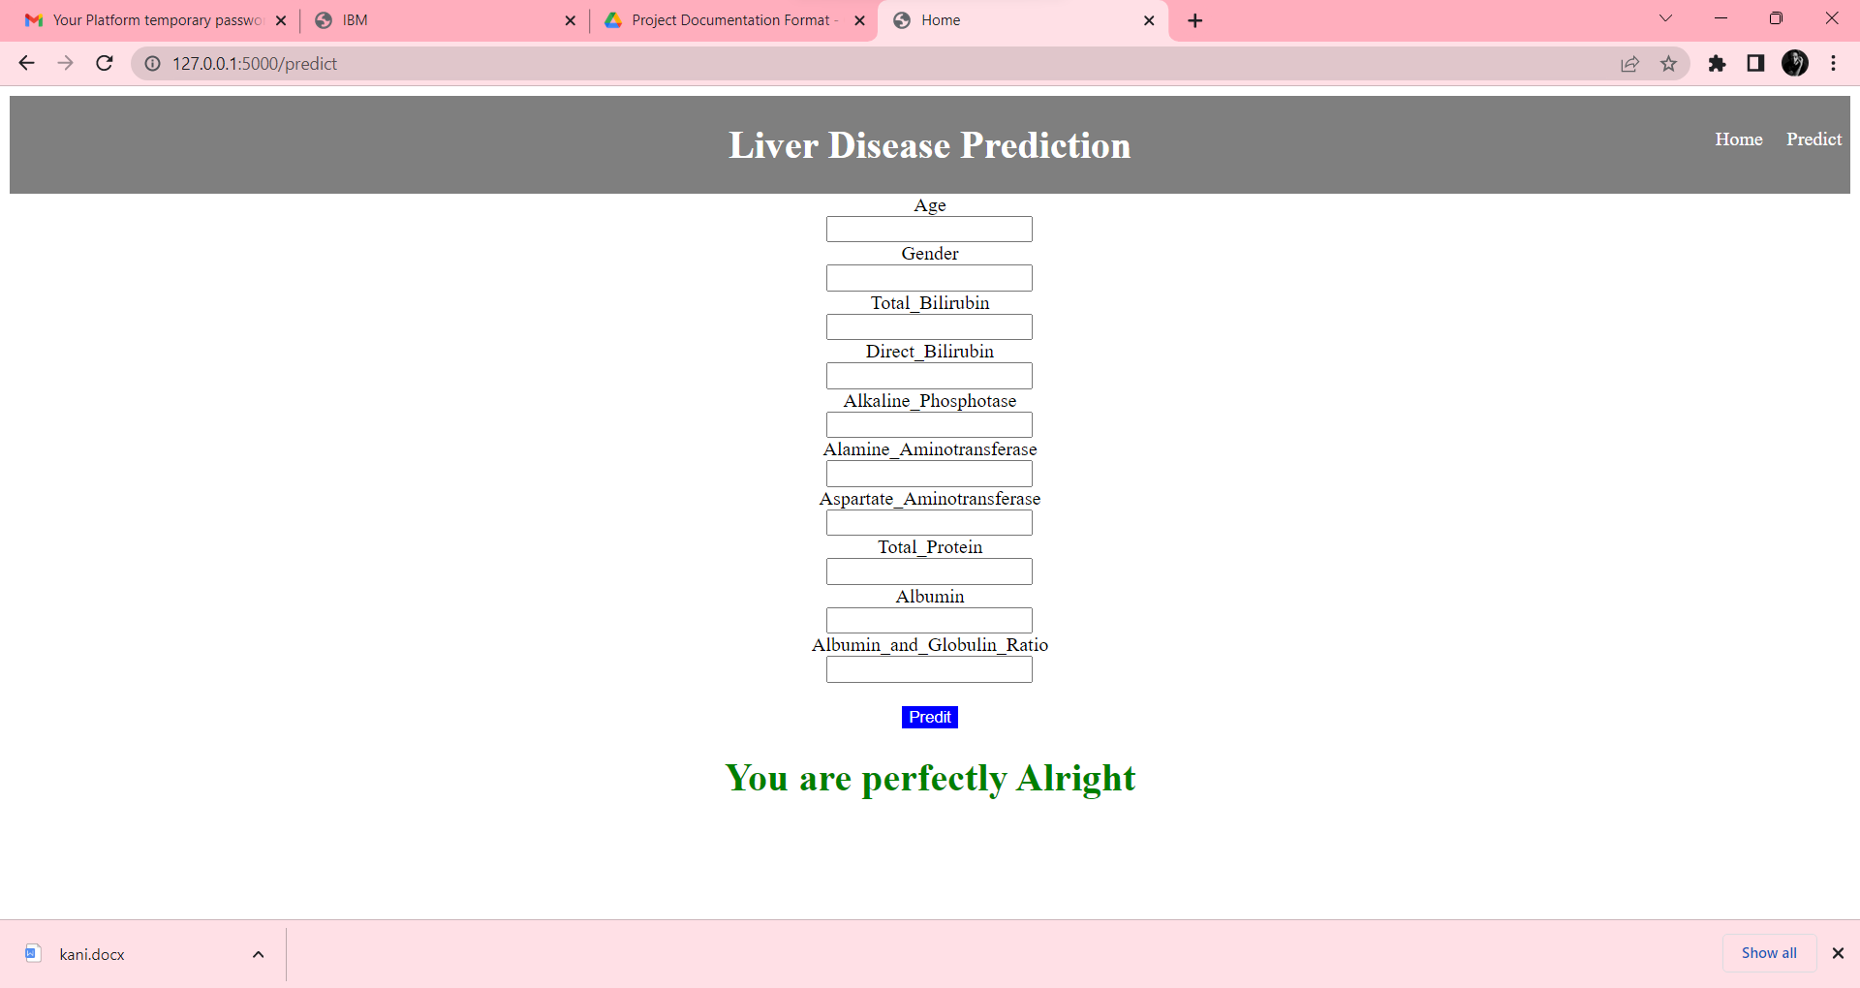

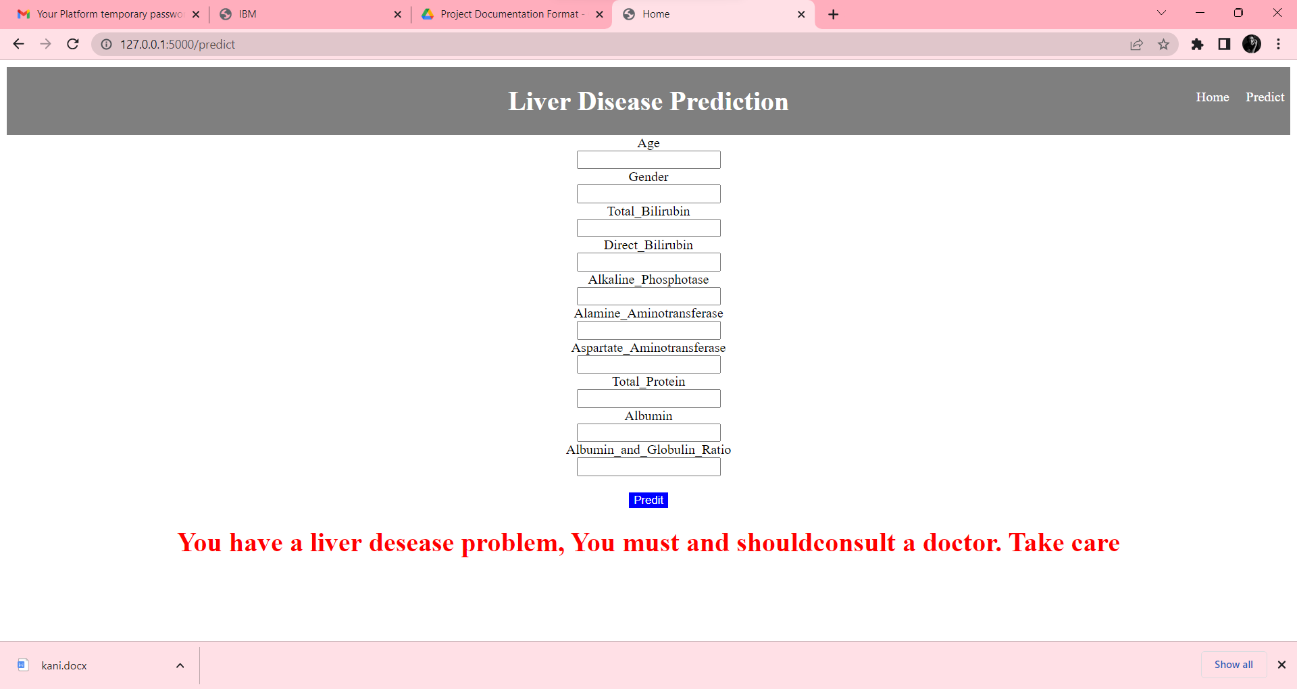

**CHAPTER 10**

**ADVANTAGES & DISADVANTAGES**

**10.1 ADVANTAGES**

* The performance classification of liver based diseases is further improved.
* Time complexity and accuracy can measured by various machine learning models ,so that we can measures different .
* Different machine learning having high accuracy of result.
* Risky factors can be predicted early by machine learning models.

**10.2 DISADVANTAGES**

* The entire system was manual.
* It fails to accurately predict a value using the KNN algorithm.

**CHAPTER 11**

**CONCLUSION**

Clinicians who are skilled at collecting noteworthy observations and categorizing them as normal or abnormal using background knowledge and other context clues can detect liver disease. Similar to how ML algorithms may help medical professionals, these algorithms can be trained to recognize the potential for liver illness. The web site which was created is useful in predicting the disease. It aims to link users who are not in the same physical location by bridging geographical divides.

**CHAPTER 12**

**FUTURE SCOPE**

Diseases of the heart and liver are growing more and more common.These will only rise in the future due to ongoing technological improvements. Despite the fact that individuals are becoming more health conscious today and enrolling in yoga and dance classes, the issue will persist due to sedentary lifestyles and extravagances that are always being introduced and improved. Therefore, in this situation, the society will greatly benefit from our initiative. Although it may be challenging to achieve such ac-curacies with very large datasets, from the findings of this experiment, one can definitely conclude that we can forecast the risk of liver illnesses.In today's world, practically everyone over the age of 12 carries a smartphone, thus we can include these solutions into an website, be very helpful to a sizable portion of society.

**CHAPTER 13**

**APPENDIX**

**Source Code:**

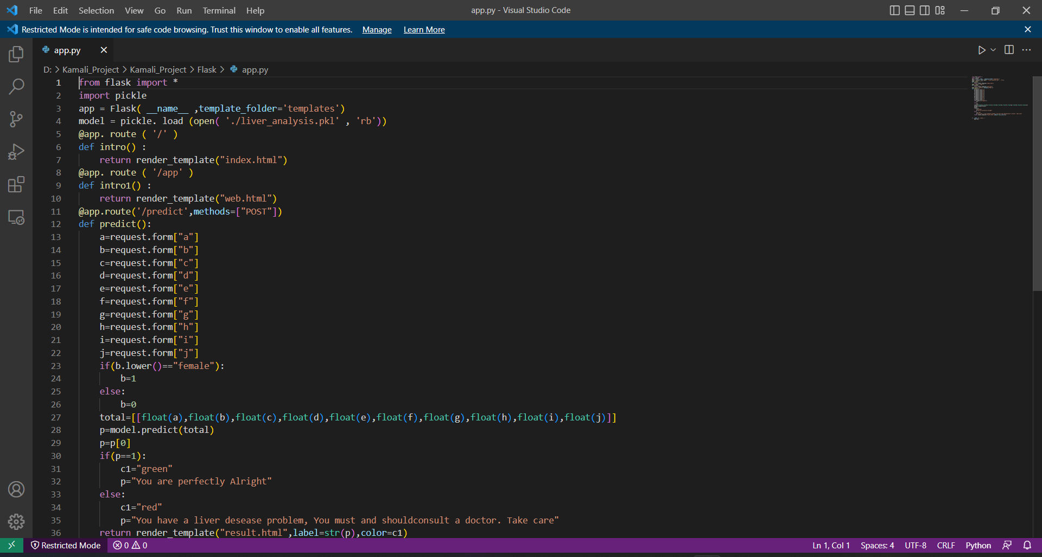

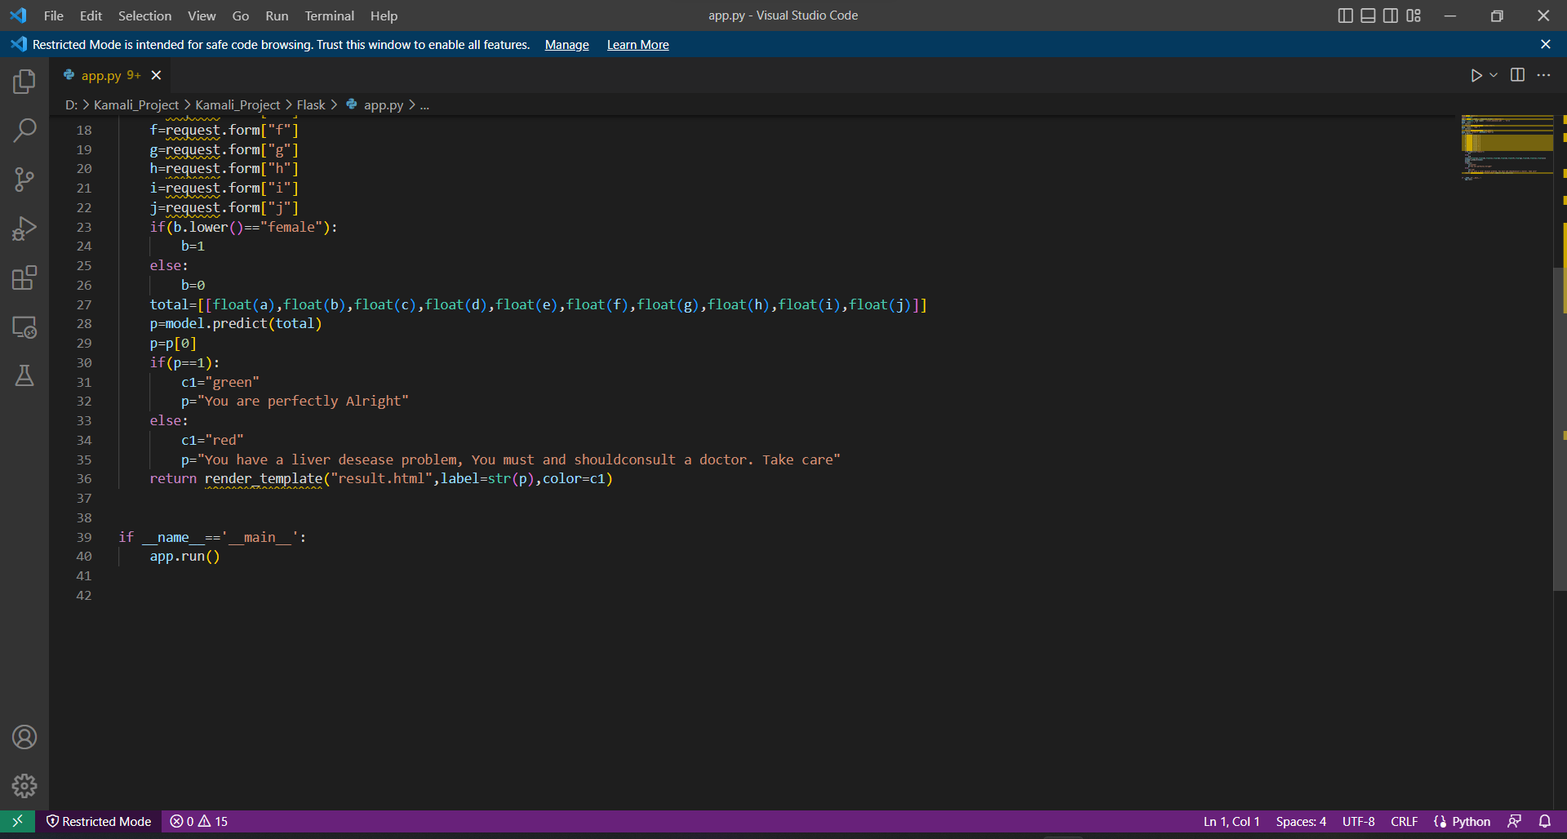

**GitHub & Project Demo Link:**

**GitHub Link: Kamali09**

**Project Demo Link:**https://www.youtube.com/embed/YWdAOw12owM